ECE322 Lab

Lab 4 Report
Part 1: Activity 1

Jason Yan

8:43, 9/24

Contents

1. Circuit Schematic Page 1
2. Circuit Analysis Page 2
3. Sample Spice Deck 3
4. DC Simulation Result 4
5. AC Simulation Result 5
6. Transient Simulation Result 6
7. Cascading Result 6

Circuit Schematic Page
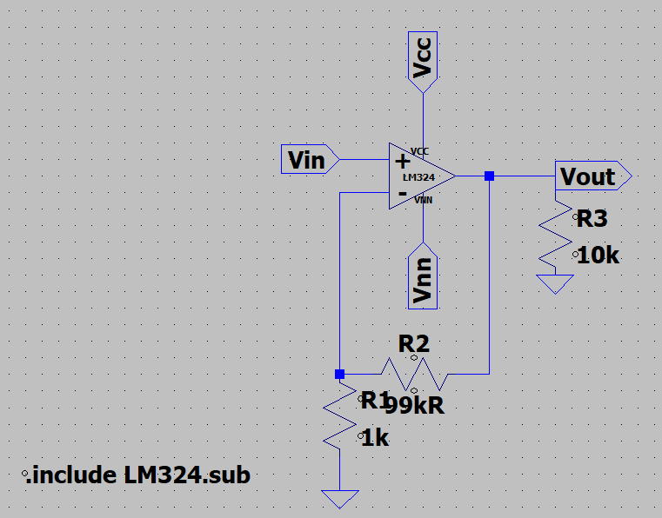
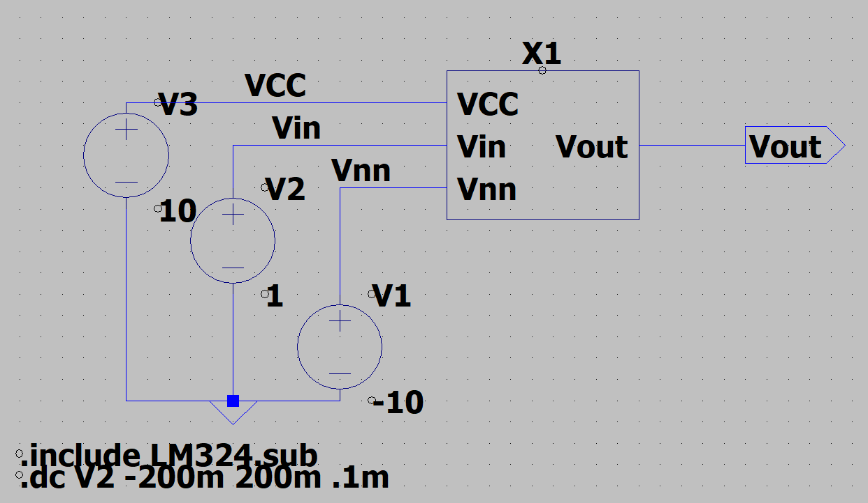

2. Circuit Analysis Page

3. Sample Spice Deck

4. DC Simulation Result
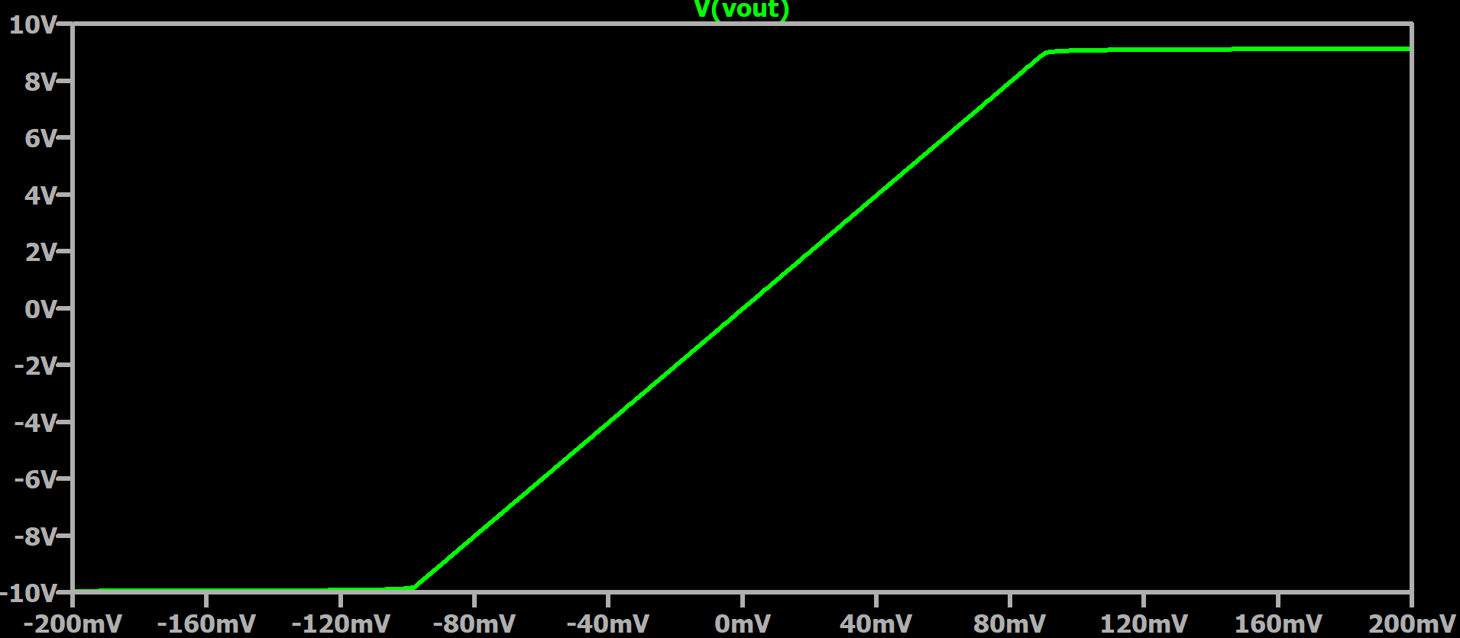
The circuit gain does relatively match the gain I calculated in Excel, however my saturation points are not the same as what I expected from the data sheet.

5. AC Simulation Result
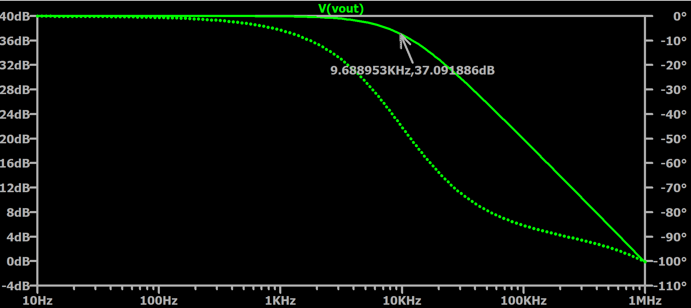
Shows asdfasdfasdf

6. Transient Simulation Result
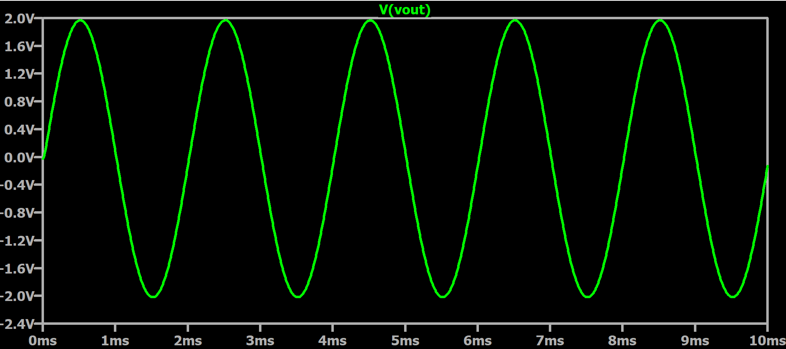
Lsndf

